EXERCICES REDIRECTIONS

1. Execute grep command with the proper regular expression in order to find the following patterns in the file pr2_exer1.txt:

(a) Lines with treball

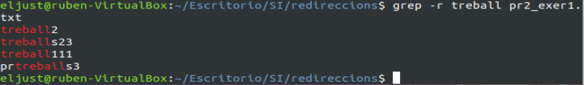

(b) Lines with 456

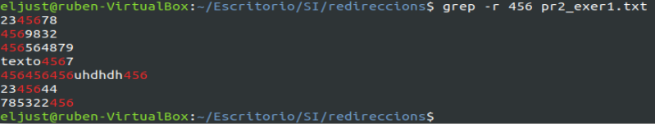

(c) Lines with at least 2 patterns 456 together (456456)

(d) Lines with at least 2 patterns 456 together (456456) and 4 as a maximun

(e) Lines ended with 7

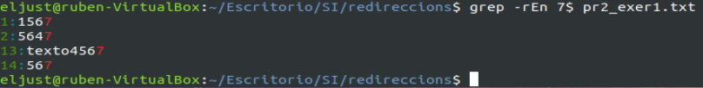

(f) Lines ended with 7 and 3 characters.

(g) Those lines started with treball followed by 2 or 3.

(h) Lines started with treball followed by number 3 as the last character.

(i) Lines without the pattern 456.

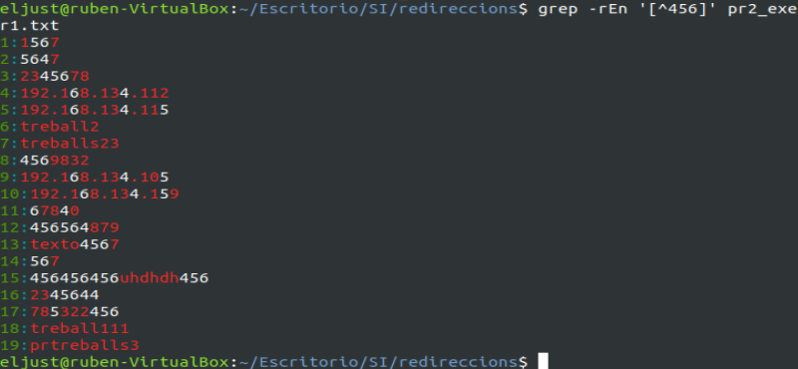

2. Do the following exercises with the last file:

(a) Redirection the first two lines into the file exer2a.txt (it doesn't exist at the moment)

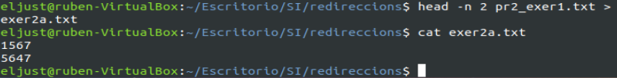

(b) Redirection the lines 6 and 7 to the exer2b.txt file.

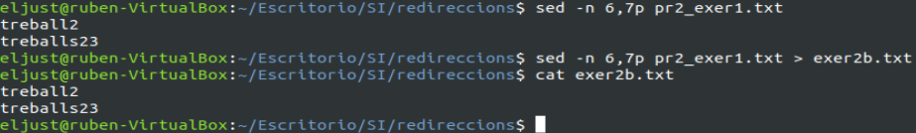
(c) Order the last file (exer2b.txt) and redirect to ordenexer2b.txt

(d) Check out whether exer2a.txt file is ordered. If not, order it and redirect to ordenexer2b.txt

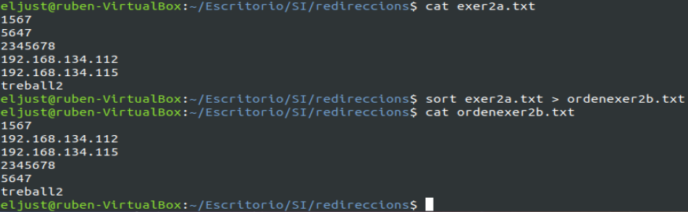

3. Create the file exer3.txt with the output of the ls -l command and do the following exercises:

(a) Remove the repetitions of the spaces and change the delimiter (the space) by #. Redirect to exer3a.txt.

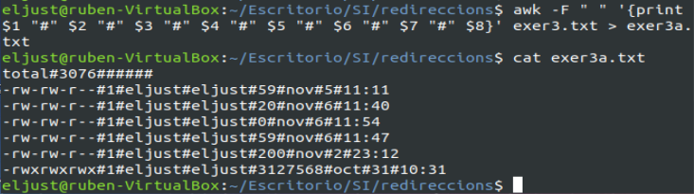

(b) Cut the 4 first characters of exer3a.txt file (just displayed on the screen)

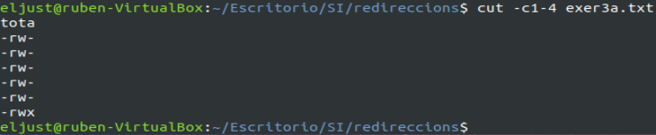

(c) Cut the fields number 3 and 5 (just displayed on the screen). Remember, you should specify what delimiter are using

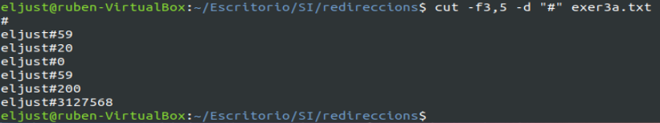

4. Use the command find:

(a) Find files modified in the last 30 minutes.

(b) Find all the files created in the exercise 2.

(c) Find those files which you are the owner.

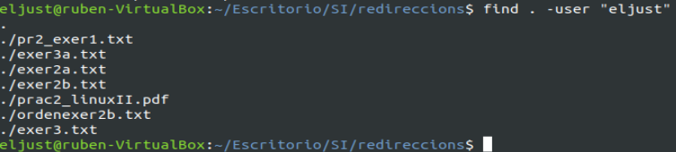

(d) Find the files the size of which is lower than 1000 kB

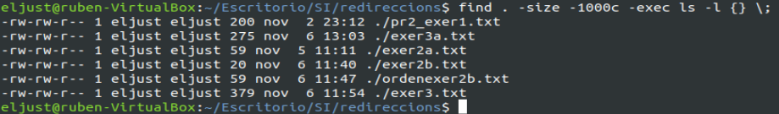

(e) Find those files the size of which are lower than 1000 Kb and list them with extended format and the greatest unit of measure.

